Peter Marsack: artwork for sale

Peter is a wildlife artist with a background in biology including time in research and policy. Over the past 25 years he has been a lead artist for the two largest ornithological publishing projects undertaken in Australia (Handbook of Australian, New Zealand and Antarctic Birds (HANZAB, Oxford University Press), and The Australian Bird Guide with its sister volume The Compact Australian Bird Guide (CSIRO Publishing), which have won multiple awards. He also illustrated A Bush Capital Year, an award-winning book on Canberra’s natural history across the seasons, working with author Ian Fraser (CSIRO Publishing 2011). He was a prize winner in the inaugural Waterhouse Natural History Art Prize and has acted as judge for the Holmes Prize for Realistic Bird Art. He has a particular interest in the evolving genre of Science Art, and in the value of field sketching as a basis for artwork. Over the past few decades he has lectured and run workshops on illustration techniques for a range of audiences.

The selection of artwork offered for sale reflects a step away from illustration for identification, and his personal take on some memorable experiences.

1 Common Bronzewings | Watercolour/gouache,  60 x 40 cm | Au $3,500 (framed, excl. shipping)

Common Bronzewing pigeons are found across almost all of Australia apart from wet forests, treeless plains and deserts. They are not seen as commonly as the name suggests, typically being quiet, shy birds of woodland and generally wary around people. They feed on seeds on the ground and rest in shade or perched in trees, as shown here. They display a lovely mix of soft colours and textures contrasting with the iridescent wing feathers for which they are named. This painting shows two birds settled on a perch in Box-Gum Woodland, a habitat common across much of south-eastern Australia. The female is perched behind the male, feathers fluffed out in relaxation. The adult male shows a bright buff forehead where the female
is grey. The partly spread wings of the male show off the iridescent patches of the covert feathers.

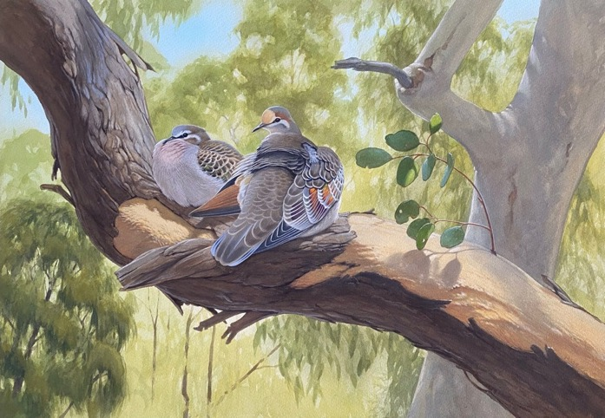

2 Himalayan Monal | Oil, 60 x 50cm | Au $5,500 (framed, excl. shipping)

For many birdwatchers an adult male Monal is simply the Best Bird Ever; getting a sighting of this giant iridescent pheasant requires effort just in reaching its high-altitude habitat. Himalayan Monal live in open upland forests to the edge of the treeline in the foothills of the Himalayas, and are found from eastern Afghanistan through Myanmar, Tibet, Bhutan, north-east India and Nepal, where it is the national bird. I saw this bird at the Se La (pass) in Arunachal Pradesh, north-east India, at an altitude of over 4000m.

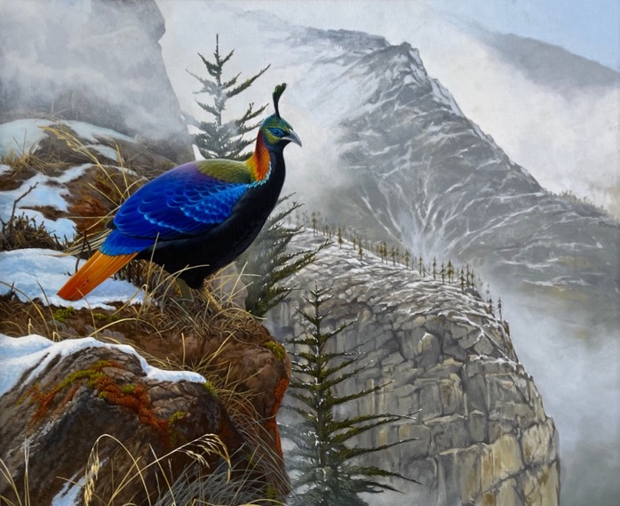

3 Peregrine and sea-cliffs | Acrylic, 60 x 75 cm | Au $4,000 (framed, excl. shipping)

Peregrine falcons are spectacular birds of prey, powerful hunters that specialise in catching birds. They are probably the fastest birds in the world, timed at over 180km/hour as they stoop (dive) on their prey. It is always a thrill to see a hunting Peregrine, but especially in open wild habitats such as the sea cliffs along the Central Coast of NSW, the inspiration for this painting. They often seem unafraid of people and will fly low overhead, screaming, if walkers get too close to their cliff nest sites. Living in Newcastle has given me the chance to watch these coastal Peregrines regularly.

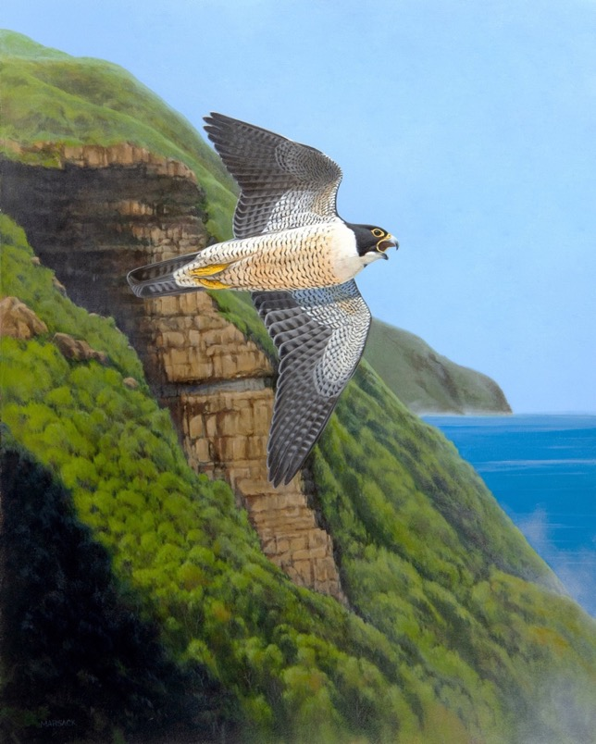

4 Sri Lankan Junglefowl | Gouache, 37.5 x 48 cm | Au $3,500 (framed, excl. shipping)

Junglefowl are recognisably the ancestors of the familiar domestic chook, which has diverged from its origins much as dogs have diverged from wolves. In wild junglefowl, females are patterned in discreet shades of brown, but adult males have spectacularly coloured feathers, often iridescent, and long plumes used in displays. They also crow just like barnyard roosters. For all the brilliance that marks a breeding male Junglefowl, they can be very hard to see in the open forests that are their native habitats.

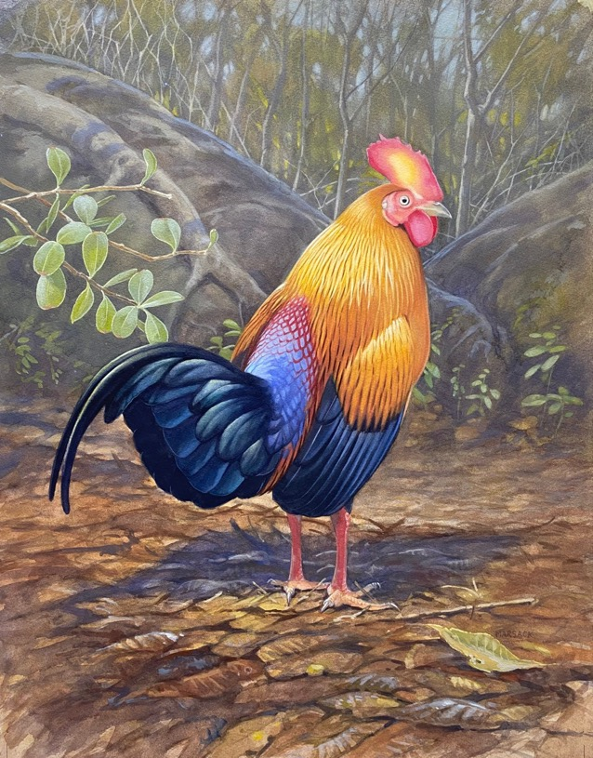

5 Black and Yellow Broadbill (with Flower Mantis) | Watercolour/gouache,  35 x 46 cm | Au $3,500 (framed, excl. shipping)
The Broadbills are a group of highly distinctive birds found in south-east Asia. With their typically bright colours, stubby wings, oversized heads and bills and staring eyes they always remind me of flying Muppets. They feed on insects and this Black and Yellow Broadbill would be very happy to take the nearby Flower Mantis as a snack. There are many species of praying mantids in tropical regions, often highly camouflaged to help them ambush their prey or for protection against predators.

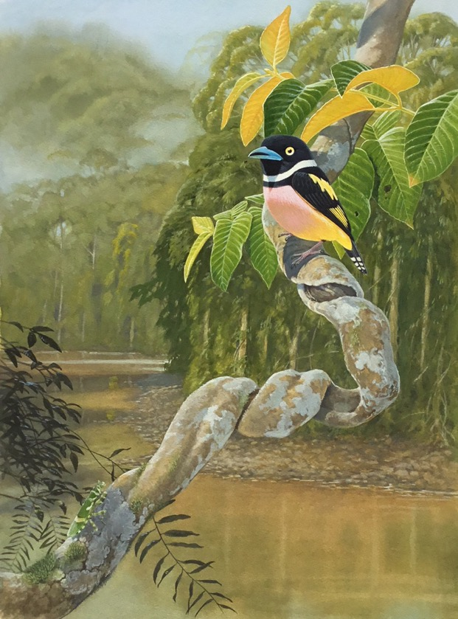
6 Wedge-tailed Eagle, Nullarbor | Acrylic, 24 x 30 in | Au $3,500 (framed, excl. shipping)

The Wedge-tailed Eagle is Australia’s largest bird of prey: a big female weighs more than four kg and can have a wingspan well over two metres. Although they are content to eat carrion including roadkill, Wedge-tails are versatile and formidable hunters, taking a range of prey from lizards, possums and parrots to feral goats, lambs and kangaroos, with multiple eagles sometimes hunting cooperatively to kill prey as large as Red Kangaroos. This painting shows a young bird perched in a dead tree patiently waiting for an opportunity to hunt in one of Australia’s expansive arid landscapes, part of the Western Australian Nullarbor.

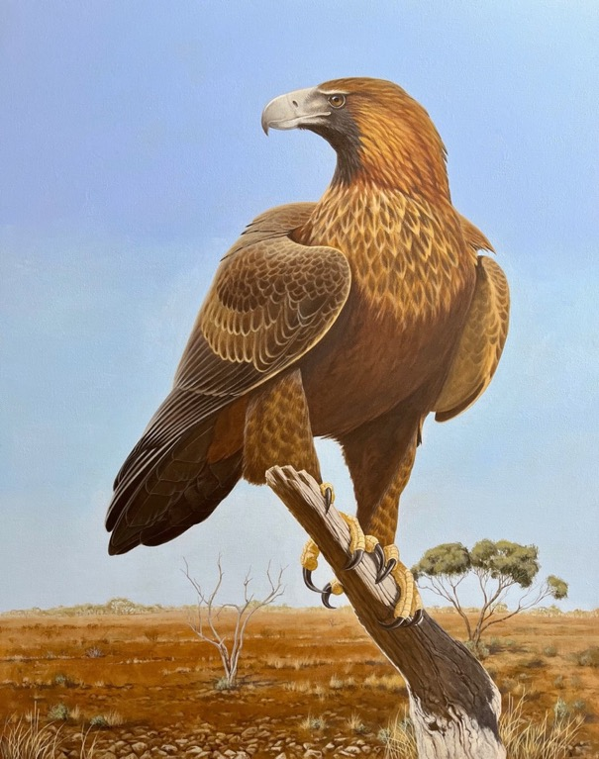

7 Pink-eared Duck | Acrylic, 16 x 20 in | Au $2,000 (framed, excl. shipping)

The Pink-eared Duck is named for the tiny patch of bright pink feathers at the side of the head, a colour accent in an otherwise subdued colour scheme in shades of brown, black and white. Its over-sized bill, dark eye patches and pink ear spots help to give it a clownish appearance. The older name of Zebra Duck refers to the black and white stripes on the flanks, much more obvious than its pink ‘ears’. Pink-ears can be seen around water anywhere in Australia, often turning up in flocks where rain brings shallow flooding. They have bills modified for filter-feeding and will swim together in groups, turning in circles to disturb water and stir up food. My painting shows a solitary bird I saw at rest in shallow water, bill tucked into its back feathers but eyes open and alert.

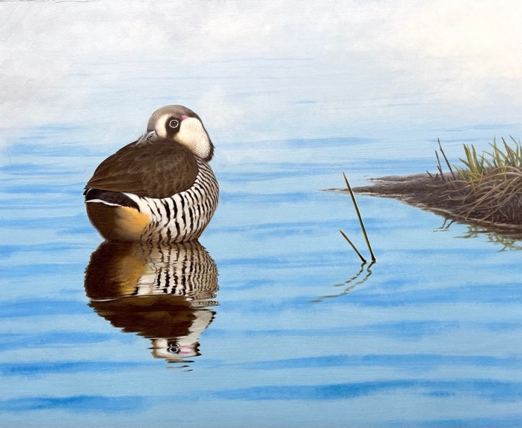

8 Banded Lapwing | Watercolour/gouache,  48 x 37.5 cm | Au $2,500 (framed, excl. shipping)

Most Australian will know the Masked Lapwing, that noisy, aggressive bird of urban parks and grassland that stubbornly chooses to breed in public areas and loudly defends its nest and young against passing cars, people and pets. The Banded Lapwing is its shyer relative, more a bird of the bush and arid inland, often found well away from water. We found this one loudly defending its nest in an area of the West Australian wheatbelt, surrounded by blooming wildflowers in Spring.

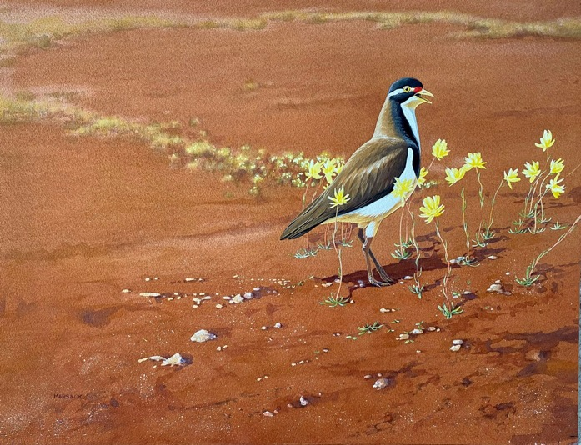

9 Latham’s Snipe | Watercolour/gouache,  52 x 35 cm | Au $S2,500 (framed, excl. shipping)

Latham’s Snipe are migratory wading birds that breed in Japan and south-eastern Siberia and migrate to south-eastern and eastern Australia. These birds weigh just 200g, but make this extraordinary 8000 km journey twice annually, via New Guinea, between the northern breeding grounds and southern foraging sites. Snipe are shy and cryptic birds, sheltering in wetland vegetation and grassland during daylight and foraging in more open muddy habitats overnight. With luck they can be seen foraging at dawn and dusk when light levels are low; even then they are extremely wary and will take flight if disturbed.

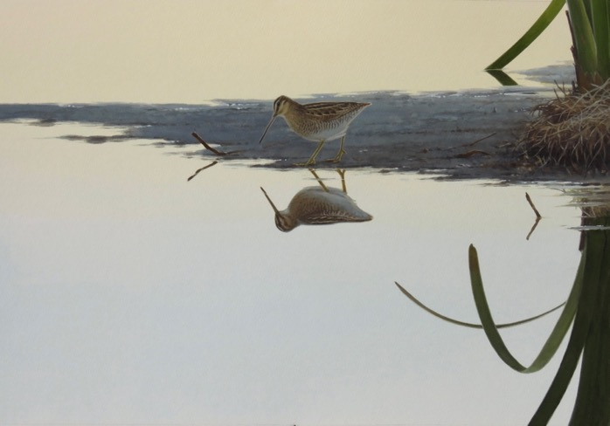

10 Platypus | Oil, 90 x 75 cm | Au $5,000 (framed, excl. shipping)

The Platypus is an icon, a uniquely Australian mammal that is one of just three species to lay eggs rather than bear live young. Although Platypus are well known they are generally difficult to see, being largely aquatic, nocturnal and shy. This painting was inspired by a rare view in full daylight, as a platypus passed beneath us as we stood on a bridge over a stream within Healesville Sanctuary. It was travelling steadily upstream, foraging as it went and paying no attention to us watching overhead. The large blunt bill suggests it was an adult male animal.
This painting was selected as a finalist in the inaugural Waterhouse Natural History Art Prize at the South Australian Museum.

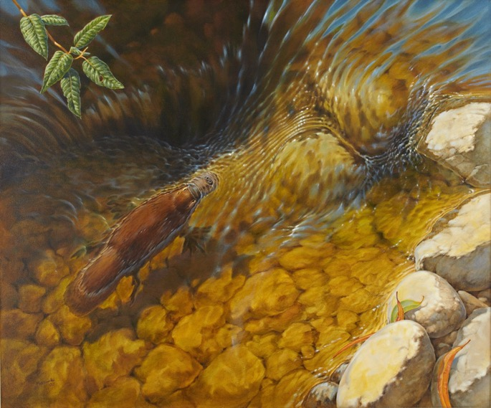

11 Tuan on Ironbark | Acrylic, 30 x 40 cm | Au $750 (unframed, excl. shipping)

The Tuan, or Brush-tailed Phascogale, is a fierce little carnivore found only in Australia, where it is threatened by habitat loss and urban build up. It survives in the less disturbed wooded habitats of wetter coastal areas of Australia. It is a nocturnal hunter that feeds mainly on insects, spiders and the like but can kill prey as large as a chicken. This painting shows a Tuan foraging at dusk, looking for prey on the trunk of an Ironbark. The Old Lady moth resting on the bark nearby would make a tasty meal.

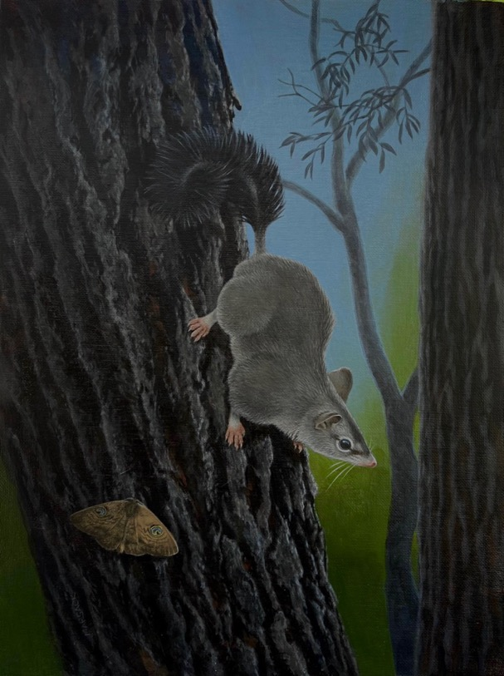

12 Red-backed Fairy-wrens | Acrylic, 40 x 30 cm | Au $750 (unframed, excl. shipping)

These are common small birds of the warmer coastal fringes of eastern and northern Australia. They like tall grassy habitats, sometimes under open woodland or around wetland margins; they also survive in remnant grassland in some urban areas. Like all Fairy-wrens, the breeding adult males are much more brightly coloured than the females and non-breeding birds. With such conspicuous colours, males that survive to become potential breeders are demonstrating their fitness to the female when she chooses a mate. Red-backed Fairy-wrens live in pairs or family groups, and young from previous seasons may help to raise the next broods of nestlings. Fairy-wrens build a well- hidden domed nest of grasses, and the female must bend her long tail around as she squeezes in to incubate her eggs or brood the nestlings. When she leaves the nest her tail will show a visible bend, one way of recognising a nesting female, like the bird in this painting.

