Have you seen this bird?
The Gang-gang Cockatoo has recently been listed as threatened in the ACT. Studies to provide information on nesting locations, diet and general behaviour have been conducted locally, for instance see, see Davey et al. Canberra Bird Notes 46,pp145-157 and
» Red Hill gang gang research summarised Red Hill Regeneration Group (redhillregenerators.org.au)
There has been no study on banded individual and questions concerning movements remains to be answered.
A male with a distinctive head pattern nested at the Aranda Bushland over the 2021-22 breeding season. The bird known as ‘Baldy’ has been reported in various locations up to 4 km from the breeding site. The pattern appears to be a permanent feature for despite moulting the same distinctive feature is still obvious.
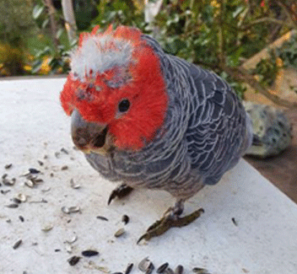

Any sightings of Baldy would be most welcome and would go some way to better understand movement patterns.
If you happen to see ‘Baldy’ could you please try to get a photo and then either post to Canberra Nature Map Home - Canberra Nature Map (naturemapr.org) or contact Michael Mulvaney mulvaney@netspeed.com.au or me chris_davey@aapt.net.au
Many thanks, Chris Davey

