**Urban Reserves camera survey for Small Mammal**

This survey will provide information on current small mammal persistence and predator abundance at the site and may help increase our understanding of habitat conditions for small mammals to persist in the landscape. It will also provide baseline information to help understand the impact of further urban development on small native mammal populations.

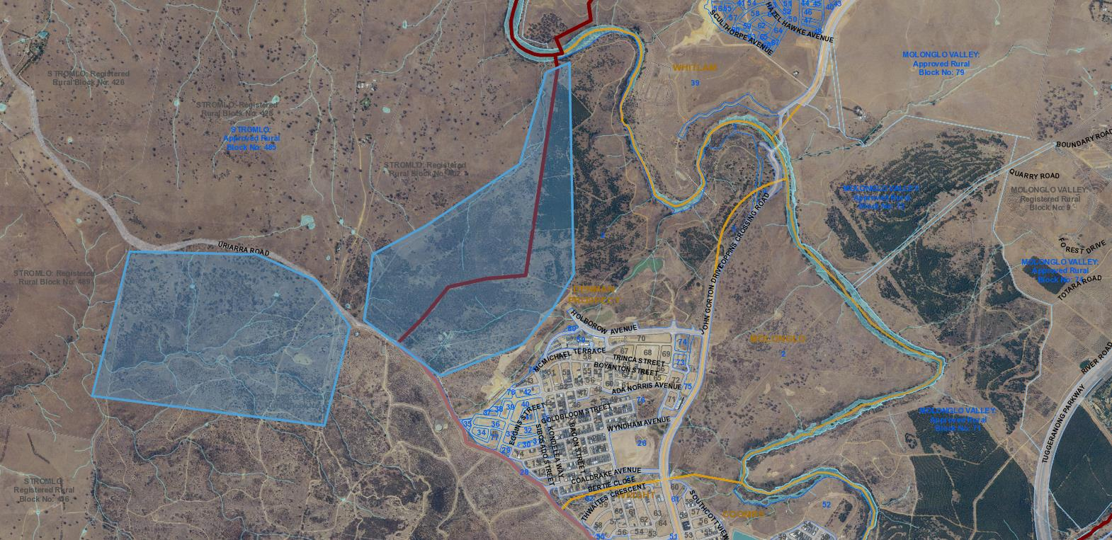The project will be conducted in two sites (see two blue polygons in the figure below). The first site will be located at Piney Hill (next to Denman Prospect Hill): dry sclerophyll forest. The second site at Stromlo Forests Park West: Blakely’s Red Gum – Yellow Box tall grassy woodlands.

We are going to put 30 white flash cameras and 16 infrared cameras at one site for four weeks (April – May) and then transfer all of them to the second site. Therefore, we may need help about camera checking and card collection (one volunteer every time), habitat assessment (one volunteer every time), and camera patrol (four volunteers every time). For camera patrol, volunteers will work by themselves.

**Urban Reserves camera survey for small mammals,**

Help out with a survey of an Urban Reserve within Canberra Nature Park to detect the population of small mammals, using baited camera traps.

For habitat assessment on (8am - 12pm & 12:30pm – 2:30pm), you will be required to:

* Work in a team of two
* Possibility of climbing over abandoned farm fence
* Hike up to 3-5km return, and
* Carry equipment for:
  + habitat assessment (about 3kg).

For camera patrol on (10 - 2pm), you will be required to:

* Work in a team of two
* Possibility of climbing over abandoned farm fence
* Hike up to 3-5km return.

For camera checking and card collection on (8am - 12pm & 12:30pm – 2:30pm), you will be required to:

* Work in a team of two
* Possibility of climbing over abandoned farm fence
* Hike up to 3-5km return, and
* Carry equipment for:
  + Camera checking (about 3kg).