Finch Central blurb
Let’s start with a picture of where to park etc.
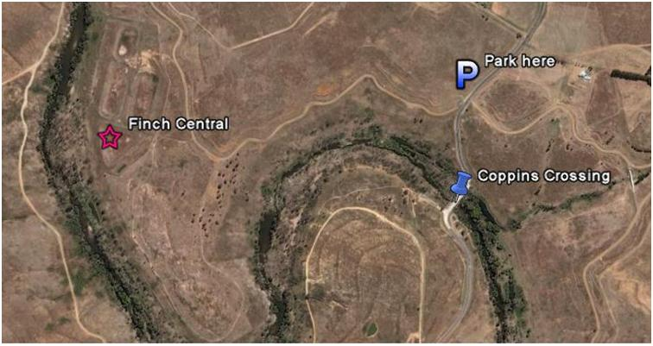
The idea is to meet at the designated spot at 9:00. We’ll then walk along the track which parallels the Molonglo until level with the old sewage ponds . En route keep an eye out for robins – especially Flame – perched on the fences bordering the track. We’ll then explore the brambly area between the track and the River. This is the area where Red-capped Robins may appear.
We will then go through a gate into the area between the ponds and the River where finches (Red-browed, Double-barred, European Gold and Diamond Firetail ) may be found. Also Scarlet and Eastern Yellow Robins. NOTE of CAUTION: Cattle which graze in Blewett’s (ex)Pines to reduce fire hazard can, and do, cross the Molonglo into this area: apparently 2 – 5cm of slow moving water do not provide a barrier. They have done a good job of trampling the brambles, briars and bracken and seem to be generally harmless. However they do riot around a bit, so anyone that is nervous around bovines may wish to be careful.
The return trip will check out the large eucalypts South of the track to see what is there. Keep an eye out for raptors at all times: in this area I have seen, at various times, Wedge-tailed and Little Eagles; Pergerine and Brown Falcons, Nankeen Kestrel, Black-shouldered Kite and Brown Goshawk. Others have seen Grey Goshawk hunting along the river in this general area.
The walking will not be strenuous and my expectation is that we will finish about noon to 1pm. I suggest that people plan to dress in layers: although there is no precipitation forecast - drat - the wind can howl down the valley.

