Inventory Size and Complexity in the Song of the American Robin
A newly discovered parallel between Humans and Robins

Hypothesis:
American Robins with larger element inventories will have more complex elements in their inventories.
Why Robins?  - Create new and unique songs at will  - Little structure rules to date  - Syllables -> Elements  - Elements create inventories  - Johnson 2006 | Humans?  - Consistently produce new and unique utterances  - Human phoneme structure  - Utterances -> phonemes -> features  - Explain sequencing  - Size Principle  - Inventory size directly linked to phoneme complexity  - Lindblom and Maddieson 1988
Data Used  - 14 recordings  - Between 30 and 40 minutes  - Collected in Spring  - Chapel Hill/Carrboro area North Carolina  - Multiple song bouts  - Between 6 and 35 elements | What are the complexity variables?  - Inventory size in terms of number of elements  - 9 elements versus 22  - Element length in terms of number of components  - 4 components versus 27  Expecting: Longer component strings in larger element inventories
[PRAAT Spectrogram Settings]  The steps for breaking down a complete inventory file:  1. Open file in PRAAT  2. Set PRAAT settings for Hz and Dynamic Range  Hz set to between 0 and 5000  Dynamic Range can be between 25.0 and 40.0  3. Zoom in for each individual element  4. Turn on intensity and use the intensity contour to mark boundaries for each element  Mark the beginning and end of the visible element with a boundary  If the minimum matches a pinch in the waveform, mark the boundary  5. Label each new component using the component type chart | [PRAAT Spectrogram Example]  Labeled Element Example  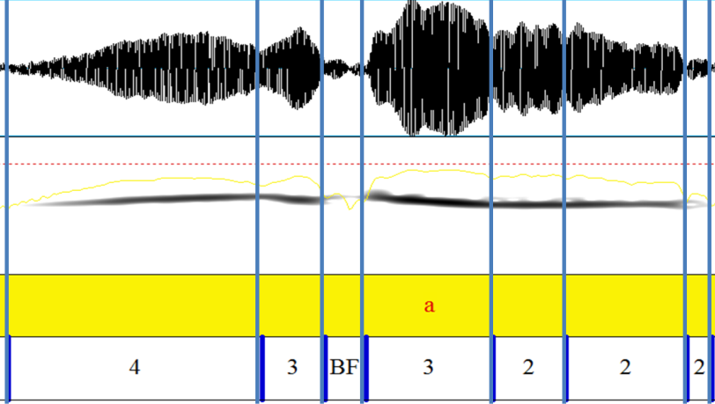
Results: Components

Results: Average Number of Components

What the results suggest  - Larger inventories contain more complex components  - Humans are not completely unique  - Multiple comparisons  - Morpheme/Element  - Phoneme/Element  - General Principle to Communication  - Model for combinatorial systems  - Probability of picking complex parts | There is still more to learn about Robins  - Component system with labels  - Testing of component prevalence  - Vertical pitch falls only above 20 elements  - Horizontal consistency most common  - Restrictions  - Components -> Elements  - Elements -> Song bouts  - Other song birds
[Working Component System]

Breaks:
- BD – break down
- BU – break up
- BF – break flat
Acknowledgements  I would like to thank the following people for their help throughout this project:  - Professor Elliot Moreton  - Haven Wiley  - Steve Johnson | Bibliography  Steven L Johnson, "Song learning and syntax patterns in the American robin and the soil characteristics of bank swallow nest sites" (January 1, 2006). Electronic Doctoral Dissertations for UMass Amherst. Paper AAI3206190.  Lindblom, Björn & Ian Maddieson (1988), Phonetic Universals in Consonant Systems. In Larry M. Hyman & Charles N. Li (eds.) Language, Speech and Mind, pp. 62-78.

